



**STRICTLY EMBARGOED UNTIL 4PM (UK) THURSDAY 29th SEPTEMBER 2016**



**Plug-In Collective  
  
*Focusrite’s Plug-In Collective brings monthly plug-in deals to registered customers***



The advent of Focusrite’s new, ultra-low latency interfaces opens up a world of new possibilities for recording and overdubbing, using multiple DAW plug-ins in real time rather than needing special cue mixes and outboard DSP.    
  
There’s no shortage of great plug-ins today, with new and exciting instruments and effects coming out all the time – but which to choose?  
  
At Focusrite, we believe in freedom – the freedom to choose the plug-ins that get musicians, producers and engineers their signature sound, exactly the way they want it. To help in the quest, Focusrite is working with some of the most innovative and prestigious plug-in companies around to provide exclusive offers, tutorial content and more.

This is the Focusrite Plug-In Collective.   
  
Every month, Focusrite offers exclusive deals from the world’s leading plug-in companies to registered Focusrite customers – and not just interface owners, but owners of any registered Focusrite product.

**In October, Focusrite has teamed up with Sound Radix to offer a free SurferEQ 2 Boogie plug-in - a version of the SurferEQ 2 plug-in exclusive developed for Focusrite customers.**

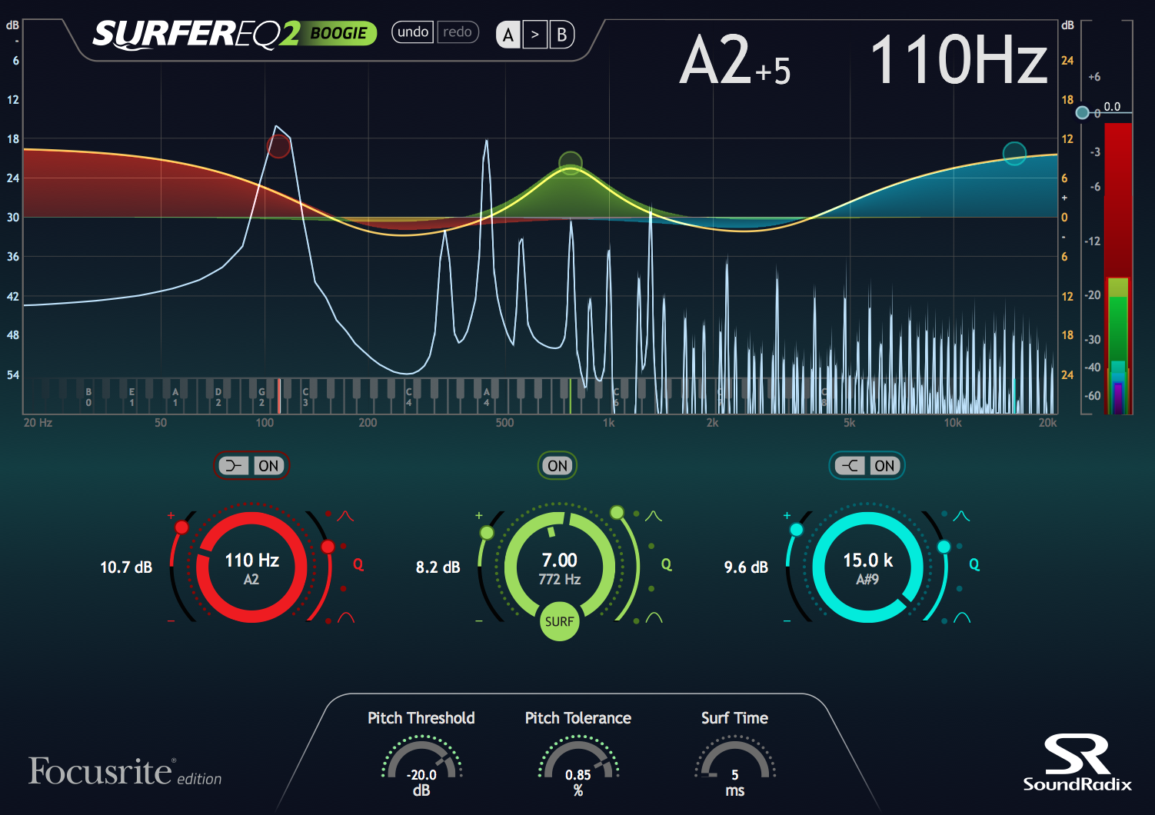

 SurferEQ 2 Boogie features 3 bands, two of which can be switched to Shelf mode, while the centre band can be switched between Surfing and static mode. Surfing mode tracks the pitch of a monophonic instrument or a vocal source and can adapt its bands' frequencies relative to the music in real-time, maintaining the natural harmonic balance of the sound source and making it possible to shape the source's timbre relative to the notes being played.

This is the latest in a line offers from the Plug-in Collective, which has to date seen collaborations with Softube, iZotope, Eventide, and now, Sound Radix.

A new offer for Focusrite customers is added every month, and registered customers receive an email with the latest offers as soon as they are available.

Photo File 1: Plug-in Collective October.png

Photo File 2: Sound Radix SurferEQ 2.png

For full details, visit <http://focusrite.com/plugin-collective>

or contact:

Hannah Bliss +1 (310) 322 5500 // [Hannah.Bliss@focusrite.com](mailto:Hannah.Bliss@focusrite.com)

Simon Poulton +44 1494 836 387// [Simon.Poulton@focusrite.com](mailto:Simon.Poulton@focusrite.com)

**About Focusrite**

The Focusrite brand was established in 1985 and the founding principles of the company were to develop products that sounded more musical, in addition to just measuring well – today, we still carry these founding principles forward in our class-leading and award-winning designs. We measure our success by the success of you, our clients, and you will find Focusrite product prominent in professional and project studios throughout the world. Based just outside of London, we work with the best design talent throughout the world to bring you the tools to enhance the way you work. Our product is made with pride and principle in a highly automated ISO 9002 factory with significant level of test by engineers who themselves are musicians and understand the part our product plays in your process.